**Alvaston Hall, Cheshire Holiday**

**19th January – 23rd January 2026**

**£399 pp (£50 single supplement)**

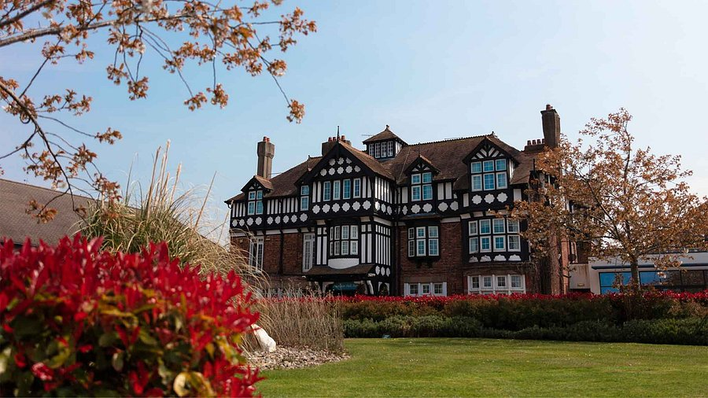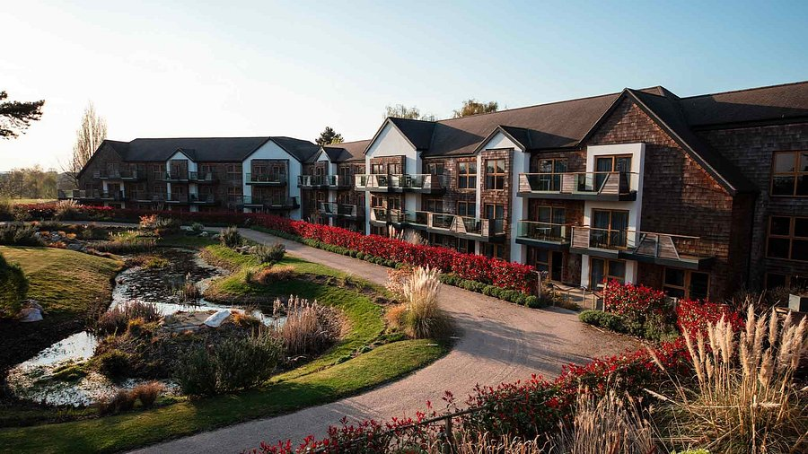

**Warners Alvaston Hall, Cheshire**

Located just five minutes from the Cheshire riverside town of Nantwich, this wonderful hotel delivers a memorable experience with its well-kept gardens and impressive historical features. All bedrooms are tastefully decorated and are en-suite with television, hair dryer and tea/coffee making facilities.

Four nights accommodation

Dinner, Bed & Breakfast

Drinks Inclusive

Two excursions – To be confirmed

Porterage

Return executive coach travel

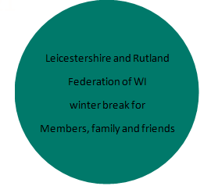

**BOOKING FORM OVERLEAF**

**APPLICATION FORM**

**Monday, 19 January – Friday, 23 January 2026**

£399.00 per person, (limited singles available - single supplement £50)

NAME…………………………...............…………..........……WI………...........…………….…….………...

ADDRESS……………………........................……………………………….…………….…………….............

……………………………........................………………………..…………………………..….………...............

TEL:NO………………………………….............EMAIL…………………………..................................……

SHARING WITH

NAME…………………………...............………………...........WI………...........……………................……

ADDRESS……………………........................……………………………….…………….……...............……...

……………………………........................………………………..…………………………..….……...............…..

TEL:NO………………………………….............EMAIL…………………………...........................................

Twin Room Double Room Single (limited availability)

**Any special requirements (e.g. Hotel, Dietary, Mobility, Dining, Coach etc.)** …......................

.…………………………………………………………………………………………….…….............................…..……………………….................

………………………………………………………………………………………….…….............................……..………………………...................

**A non-refundable deposit of £50.00 per person is required, forward application forms to: -**

WI House, 135 Loughborough Road, Leicester LE4 5LQ with a deposit.

**Remaining balance to be paid on or before 13th October 2025**

Any queries please contact [wihouse@lrfwi.org](mailto:wihouse@lrfwi.org) / 01162661342

**Cheques made payable to ‘L&RFWI’ or**

**Direct bank transfer to - L&RFWI Sort code: 60-02-17 Account number: 24626546**

**IT** **IS IMPORTANT THAT YOU HAVE PERSONAL TRAVEL INSURANCE IN CASE OF CANCELLATION.**

**Emergency Contact Information** –Please provide contact details of whom you wish us to contact.

NAME: …………………………………………………………………........................................…….………………………….………………......

RELATIONSHIP: ….………………………………………………………..........................................……………………………………………...

CONTACT NOS: ……………………………………… MOBILE: …….........................................…………………………….……….……….