Bournemouth Holiday

16th January – 20th January 2023

£225 per person (single supplement)

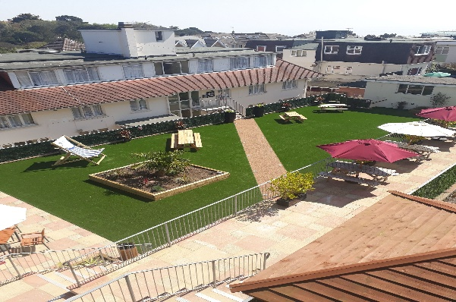
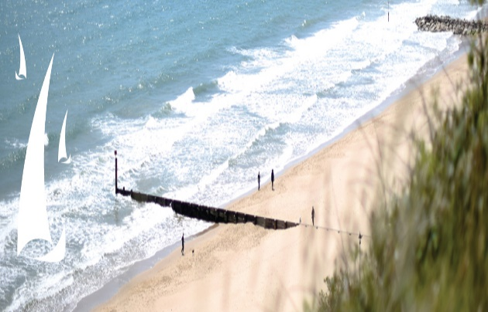
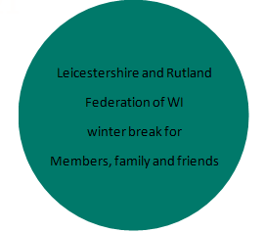

Riviera Hotel Bournemouth

The Riviera Hotel is close to Alum Chine which is at the very west of Bournemouth and is famous for its Blue Flag Award-winning sandy beach, beautiful wooded Chine spanned by a splendid Suspension Bridge and the Green Flag Award-winning Alum Chine Tropical Gardens.
It is close to the chic shopping and eateries of Westbourne and is a mere 20-minute stroll along the prom to Bournemouth Pier and town centre in one direction – or to the famous Sandbanks and Poole Harbour in the other.

Just look at what’s included
Four evening meals
Four night’s accommodation
Four buffet breakfasts
Daily activities available
3 Nights entertainment
½ price drinks from 18:00 to 22:00*
Porterage
Return executive coach travel

Two excursions plus one optional excursion - details to follow later

*50% off drink promo from 6pm to 10pm on managers selected drinks

BOOKING FORM OVERLEAF
APPLICATION FORM
Monday, 16 January – Friday, 20 January 2023
£225.00 per person limited singles available (supplement may apply)
NAME…………………………...............…………..........……WI………...........…………….…….………...
ADDRESS……………………........................……………………………….…………….…………….............
……………………………........................………………………..…………………………..….………...............
TEL:NO………………………………….............EMAIL…………………………..................................……
SHARING WITH
NAME…………………………...............………………...........WI………...........……………................……
ADDRESS……………………........................……………………………….…………….……...............……...
……………………………........................………………………..…………………………..….……...............…..
TEL:NO………………………………….............EMAIL…………………………...........................................

Twin Room Double Room Single (limited)

Any special requirements (e.g. dietary, mobility, dining, coach etc.) ……….............................……………………....
.…………………………………………………………………………………………….…….............................…..……………………….................
………………………………………………………………………………………….…….............................……..………………………...................
A non-refundable deposit of £50.00 per person is required, forward application forms to: -
WI House, 135 Loughborough Road, Leicester LE4 5LQ.
Remaining balance to be paid on or before 7th November 2022.
Any queries please contact Maxilyn Geary email maxilyngeary@lrfwi.org or mobile 07519974987
Cheques made payable to ‘L&RFWI’ or direct bank transfer to L&RFWI
Sort code: 60-02-17 Account number: 24626546

IT IS IMPORTANT THAT YOU HAVE PERSONAL TRAVEL INSURANCE INCASE OF CANCELLATION.
Emergency Contact Information –Please provide contact details of whom you wish us to contact.
NAME: …………………………………………………………………........................................…….………………………….………………......
RELATIONSHIP: ….………………………………………………………..........................................……………………………………………...
CONTACT NOS: ……………………………………… MOBILE: …….........................................…………………………….……….……….

