
Cricket St Thomas, Somerset Holiday
18th January – 22nd January 2027
£429pp
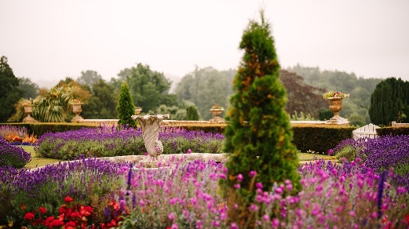
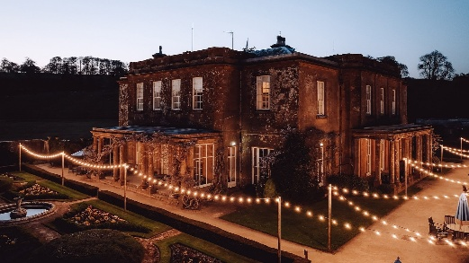
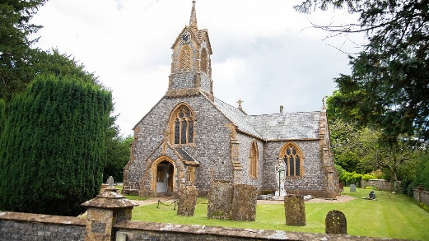
(£50 Single Supplement)

Cricket St Thomas, Somerset
Escape to the heart of Somerset and live the good life at this beautiful 18th century manor house, surrounded by gardens designed by Capability Brown. Explore the grounds, which include the 12th century Church of Cricket St Thomas, or enjoy lake views while you unwind in elegant lounges and tea rooms that famously featured in the TV sitcom To The Manor Born. Enjoy unmissable evening entertainment in the must-go Late Lounge.

Signature Room
Signature rooms are a special retreat. They're the dream ticket if you're longing for a super-soft duvet and too-many-to-mention extra little touches. In addition to what’s included in every room, you’ll also enjoy: Welcome amenities including soft drinks, still and sparkling water and nibbles, Milk and biscuits to accompany your tea, Fluffy white robes (available on request), Drinks cooler for your refreshments, Cosy chairs with reading lights, Telephone
Single Signature £529
Double/Twin Signature £454PP

- Four nights accommodation
- Dinner, Bed & Breakfast
- Drinks Inclusive
- Porterage
- Return executive coach travel
- Excursions TBC

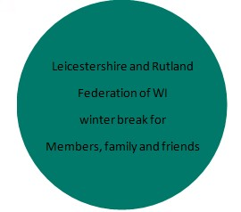
BOOKING FORM OVERLEAF
APPLICATION FORM
Monday, 18 January – Friday, 22 January 2027
£429.00 per person, (limited singles available - single supplement £50)
Signature Rooms available at extra cost.
NAME…………………………...............…………..........……WI………...........…………….…….………...
ADDRESS……………………........................……………………………….…………….…………….............
……………………………........................………………………..…………………………..….………...............
TEL:NO………………………………….............EMAIL…………………………..................................……

SHARING WITH
NAME…………………………...............………………...........WI………...........……………................…… ADDRESS……………………........................……………………………….…………….……...............……...
……………………………........................………………………..…………………………..….……...............…..
TEL:NO………………………………….............EMAIL…………………………...........................................

Standard Twin Room £429pp Double Room £429pp Single (limited availability) £479

Signature Twin Room £454 Signature Double Room £454 Signature Single (limited availability) £529

Any special requirements (e.g. Hotel, Dietary, Mobility, Dining, Coach etc.) …......................
.…………………………………………………………………………………………….…….............................…..……………………….................
………………………………………………………………………………………….…….............................……..………………………................... A non-refundable deposit of £50.00 per person is required, forward application forms to: -
WI House, 135 Loughborough Road, Leicester LE4 5LQ with a deposit.

Remaining balance to be paid on or before 13th October 2026
Any queries please contact wihouse@lrfwi.org / 01162661342
Cheques made payable to ‘L&RFWI’ or
Direct bank transfer to - L&RFWI Sort code: 60-02-17 Account number: 24626546

IT IS IMPORTANT THAT YOU HAVE PERSONAL TRAVEL INSURANCE IN CASE OF CANCELLATION.
Emergency Contact Information –Please provide contact details of whom you wish us to contact.
NAME: ………………………………………………………………….......... RELATIONSHIP:….………………………………………………………..........
CONTACT NOS: ……………………………………… MOBILE: …….........................................…………………………….……….……….

